Excel Assignment
- Create a new workbook and save it as yourname.xlsx
- Rename Sheet1 as “Expenses” and type the following data into it:
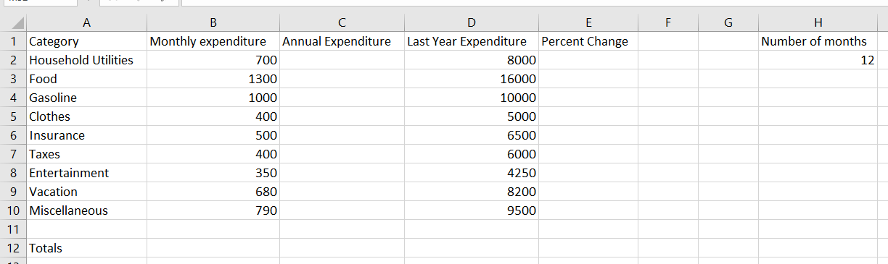
- Insert a new row above row 1. Type “Expense Plan” in A1 and merge and center cells A1:F1.
- In cells C3:C11, insert a formula that will multiply monthly expenditure by number of months(H3). Copy the formula to the rest of categories.
- In cells E3:E11, insert a formula that will calculate the percentage change as follows:

$$Percentage change=\frac{Annual Expenditure-Last year Expenditure}{Last year expenditure}$$
- In cell F2, type the text “Increase/Decrease”.
- In cells F3:F11 insert a formula that will display “Increase” for Items with positive percent change, “Decrease” for items with negative percent change and “Constant” for those items with zero percent change.
- Delete row 11, and in cells B12:D12, insert a formula that will add the totals for each column. Copy the formulas in E11 and F11 to E12 and F12 respectively.
- In cells A13, A14, A15 type “Average”,” Lowest”, ”Highest” respectively.
- In cells B13, B14, B15 type formulas that will return the average, lowest and highest values respectively for the Monthly expenditure. Copy the formulas to Annual Expenditure and Last Year Expenditure.
- Format cells A1:F1 to Bold, Italics, Underlined, Font size 15, Font Style: Arial.
- Format row 2 to bold, font size 13 and Font style: Arial.
- Format cells in A3:H15 to font style: Times New Roman, Font size: 12.
- Add Borders to all cells in A1: F15.
- Format cells in B3:D15 to Accounting format, with Chinese (China) symbol ¥, with 2 decimal places.
- Format cells E3:E12 to percentage format with 2 decimal places.
- Add your name, Date and File Path in the Left, Center and right section of the Header. Also add page number in the center section of the footer and Reg No in right section of footer. Change orientation to landscape and then print only cells A1:F15, making sure it fits on one page only.
- Print cells A1:F15 again with headers and footers as above, but this time display formulas.
- Print values of cells A1:F15 again with headers and footers as above, but only show items with negative percent change. Re-arrange the items in increasing order of Annual expenditure.

